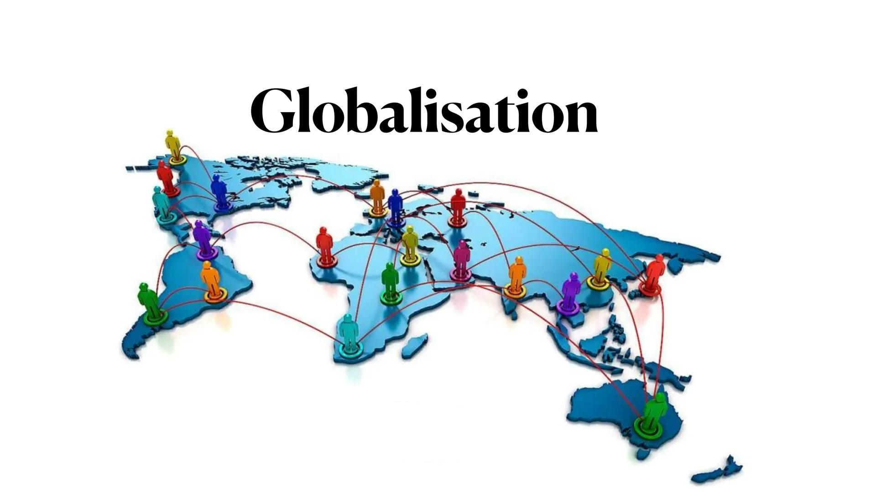

Assessing the impact of Globalisation on Economic, Social and Environmental dimensions (A Pre-Covid Analysis)

Report by:  
Ivan Das  
Prantika Mukherjee  
(Presidency University, Kolkata)  
Department of Economics

*The Multifaceted Impact of Globalization   
Exploring Economic Drivers and Social Disparities through FDI, Trade, Income Inequality and indicators of Quality of Life*

1. **Introduction**

**Abstract:**  
This study investigates the various effects of globalization on economic growth, social development, and inequality through an analysis of the Human Development Index (HDI), Gender Development Index (GDI), and GDP per capita for different income groups. Applying the KOF Globalization Indices and regression analysis, this paper argues that while globalization helps in economic growth and technological change, it increases income disparity and the ability to disadvantage marginalized groups. The results support the mixed process of globalization as an engine for upward mobility and innovation as explained by mobility matrices but also a driver of persistent inequality. The study, therefore, advocates for policy frameworks that can harness the benefits of globalization inclusively.

*Keywords: Globalization, economic growth, social development , mobility, inequality*

At the end of the 1970s of the last century, Krugman warned of the advent of a new economic phenomenon, the so-called globalization, which, if due measures were not taken, would sooner or later end up dominating the international economic concert, as finally happened. Globalization, as characterized by increased interconnectedness via trade, investment, technology, and cultural exchange, has revolutionized economies and societies worldwide. It has opened up markets, fueled innovation, and allowed developing nations like China and India to accomplish unprecedented growth through global economic integration. Globally, cultures have been enriched, and the exchange of ideas and values catalyzed; global consciousness on issues such as climate change and public health has increased.  
However, as (Stiglitz,2002) argues, globalization's benefits are unevenly distributed, creating significant challenges alongside its advantages.   
At an economic level, globalization has enhanced efficiency, encouraged competition, and opened new avenues, especially in developing economies, where multinational corporations have led to job creation. However, its interdependence has made it more vulnerable, as evidenced by the 2008 financial crisis, which spread globally within days of its outbreak (Rodrik, 2011). In addition, low-skilled workers in the developed nations are made redundant through outsourcing and automation, while widening the wage gap.  
Globalization also serves to exacerbate social inequalities by establishing strong areas in which cities thrive while other rural ones experience no benefits. Another aspect (Milianovic ,2016) focuses on is the exploitation of labor in low-income countries and the concentration of wealth among elites, which increases income inequality. Environmental degradation continues to be a pressing concern due to industrial expansion and global transportation networks.  
In short, globalization is a double-edged sword. It promotes growth and cultural exchange, yet vulnerability, inequalities, or environmental challenges expose the problem. "Globalization is not inherently good or bad; it is what we make of it," says (Stiglitz,2002). The difficulties stated above must be addressed to develop a more equal and sustainable global future.

1. **Literature review**

A plethora of research demonstrates that globalization positively affects economic growth. According to Dollar and Kraay(2004)**,** globalization works through trade openness: the economic prosperity of developing countries is supported by markets, advanced technology, and foreign direct investments. To define globalization, Dreher followed the explanations of Clark (2000), Norris (2000), and Keohane and Nye (2000:4). He summarized that “globalization is meant to describe the process of creating networks of connections among actors at multi-continental distances, mediated through a variety of flows including people, information and ideas, capital and goods. Globalization is conceptualized as a process that erodes national boundaries, integrates national economies, cultures, technologies and governance and produces complex relations of mutual interdependence” (Dreher, 2006:1092)

The globalization of labour markets has presented both opportunities and challenges. According to studies by Feenstra and Hanson (1996), globalization is a job destroyer in less successful sectors, but creates new high-tech jobs with strong export orientation. The literature contains a recurrent theme regarding the unequal economic benefits of globalization. The increasing concentration of wealth making clear how globalization aggravates existing inequalities, privileging returns to capital (liberated through free markets) over returns to work (Piketty,2014). On the other hand, Bhagwat (2004)has argued that the problem lies not with globalization but with policy frameworks.

The relationship between globalization and economic growth has been previously analysed by Dreher (2006) based on the KOF index**1**, which is a broad contextualized indicator of globalization. This study combines earlier analyses of globalization in terms of economic, social, and political dimensions.   
  
Using high quality econometric techniques it uses panel data from 123 countries in the years between 1970 and 2000 to detect the causal effect of globalisation on growth. The results demonstrate that globalization really spurs growth. The dimensions that are most strongly associated with growth correspond to real economic flows and restrictions in the industrial countries. In addition, though somewhat less strongly, information flows also contribute growth while political integration does not.

*1. The KOF Globalisation Index using a scale from 0 to 100, measures the economic, social and political dimensions of globalisation. It is used to monitor changes in the levels of globalisation of different countries over a long period.*

This quote makes reference to the research of (Edwards ,1997), who devotes his article to this problem formed by the effects of trade policy on economic growth and on income distribution in all developing and developed economies. One such paper *(Atif, Syed Muhammad and Srivastav,2012)* sheds light into if globalisation has enabled entrance to income inequality through its econometric analysis utilizing a cross-sectional data set of 68 countries. However, it has a serious drawback, which is the use of cross-sectional data and the fact that globalization studies usually provide most of their change over time.  
Another research conducted (*Sapkota, Jeet Bahadur,2011*), assist the study which considers the impacts of globalization on quality of life with special focus on human development, gender development and human poverty in less developed countries. Employing the fixed effect estimator in a panel data analysis of 124 developing countries for nine years beginning in 1997, it states that globalization (in terms of its overall indexes and major components) sustains both human and gender development and alleviates human poverty significantly.

From our analysis of the existing literature we have found some gaps to ponder upon and direct our research. Milanovic (2016) and Dollar and Kraay (2004) suggested that globalization can reduce within-country inequality, particularly in developing countries integrated into the global economy. Our results in the paper try to find a contradiction to their results and prove that globalization exacerbates inequality within countries or undermines the poor's well-being.   
Frankel and Rose (2005) suggest that international trade and investment can facilitate the adoption of cleaner production methods and environmentally sound technologies in developing countries. Moreover, globalization fosters global environmental awareness, leading to collaborative efforts to address transboundary environmental challenges.(Young et al., 2020). However our study challenges these findings as depicted by scatterplots on how globalisation leads to negative impact on environment like rising Co2 emissions and deforestation, both of which are major economic concerns.

1. **Research Objective**  
   This research works to explores the relative significance of nature and globalization impacts on social and economic factors with particular emphasis on Human Development Index**2** (HDI) and Gender Development Index**3** (GDI), GDP per capita, Income Inequality. Making use of the KOF Globalization Indices (economics and political) along with FDI, trade, education, and population growth, the study will attempt to explain the intertwined relationships between globalization and other aspects of development worldwide. In addition, this study also intends to examine the variations between the different categories of countries, namely low, middle and high-income countries revealing the beneficial and adverse impacts of globalization.
2. **Analyzing the Trends and Key Indicators of Globalization**Globalisation is a highly contested concept and means different things to different people  
   (Bardhan, 2006), hence it brings in both positive and negative feelings in the minds of different people and groups (Scholte, 2005). Because of this reason, development practitioners defines globalization pretty vaguely  and understands it as real cross-border interactions and exchanges (Goldin and Reinert, 2007:2).Even though globalization is mostly seen as economic terms, social and political dimensions cannot be ignored. In fact, cross-national connections are created in economic, political, cultural, social, and environmental domains. Following the definition and measurement of globalization in terms of KOF indexes, Figure 1 presents the comparative trends of globalization across Developed, Emerging and Developing economies from 1990 to 2019.**4**

*2.* *The Human Development Index (HDI) measures a country's average achievements in human development across three dimensions: health, education, and standard of living. HDI = (Health Index +Education Index +Income Index)/(⅓).  
3. Gender development Index(GDI) measures a country's gender development by assessing the gaps between men and women in education, life expectancy, and wealth. GDI is the ratio of female HDI to male HDI  
4. Here US, India, Congo Democratic Republic has been chosen as the representatives for Developed, Emerging and Developing economies respectively.*

As evident from the graph, the Developed nations consistently score high index, benefiting from robust trade relationships, cultural exchange, and political integration. Emerging economies show significant upward trends, indicating growing participation in international trade and global networks. Developing nations lag behind, reflecting limited access to global systems and the slow pace of economic and social integration. The graph underscores globalization’s uneven progress, with developed and emerging economies reaping more substantial benefits than developing nations.  
This study uses regression analysis to take into account some of the actual globalization-related variables in order to supplement the analysis from the KOF index. This not only clarifies the connections between these important aspects of globalisation and quality of life, but it also checks the consistency of the findings, which eventually improves the study's dependability. In that the most proxy factors for globalisation were taken into consideration,. Thus, for its disaggregated analysis, this study makes use of trade, foreign direct investment and ICT.   
The comparative trends of some elements of globalization between Developed, Emerging and Developing economies are shown in Figure 2 on its four parts (2a-2d).   
Figure 2(a) shows the dramatic increasing trend of IT development in recent decades in each category of countries from 1980-2019. Developed countries had the highest rate of growth, followed by emerging and developing countries who saw a more rapid increase from around 2004 and 2009 onwards respectively. This trend reflects the spread of mobile technology and its integration into daily life in various regions, contributing to globalization by facilitating communication and connectivity.   
Figure 2(b) shows that developed countries generally experienced higher FDI inflows compared to emerging and developing countries. Emerging economies witnessed a significant increase in FDI inflows, particularly around 2005-2007. The graph suggests that globalization has led to increased cross-border investments, with emerging markets becoming more attractive destinations for FDI.   
Figure 2(c) shows, trade flows as a percentage of GDP revealing divergent trends across Developed, Emerging, and Developing economies grom 1980 to 2019. Developed countries exhibit a gradual increase in trade flows, peaking in 2011 before stabilizing with minor fluctuations. Emerging economies show a consistent upward trend, particularly from 2002 to 2011, followed by a modest decline. Developing economies experience significant growth, especially after 2000, peaking around 2010, and then displaying volatility. These patterns reflect the rising integration of Emerging and Developing economies into global trade, with Developed economies maintaining a steady but less dynamic trade share.   
Finally, Figure 2(d) shows the importance of remittances to each type of country. The graph suggests that globalization has facilitated increased migration and, consequently, a rise in remittances, particularly for emerging and developing countries. However, developed countries generally received lower remittances compared to emerging and developing countries. Hence, Remittances play a crucial role in these economies, contributing to economic growth and poverty reduction.

1. **Globalization’s Paradox  
   5.1 Bridging Markets, Widening Gaps**  
   The graphs provide insights into unemployment rates and income inequality trends across developing, emerging, and developed economies.

Figure 3(a) shows that developing countries have the lowest unemployment rates, likely due to the predominance of informal employment, where individuals often engage in subsistence activities. Developed economies exhibit moderate unemployment rates, stabilized by strong labor market institutions and social safety nets. Emerging economies, however, face the highest and most volatile unemployment rates, reflecting structural adjustments, economic vulnerability, and incomplete integration into global markets.

Figure 3(b) highlights income inequality through the GINI index. Developing countries show relatively low inequality, as overall incomes remain low and disparities are less pronounced. In contrast, globalization's benefits in emerging and developed economies have been disproportionately reaped by wealthier segments of the population, exacerbating inequality. This is particularly evident in emerging economies, where rapid economic growth often outpaces the development of inclusive policies. In developed economies, while inequality remains relatively lower than in emerging markets, globalization has also led to a widening gap between high- and low-income groups.

* 1. **Globalization and Environment**Globalization has played a significant role in shaping economic and social structures worldwide, but its environmental consequences remain a contentious issue. The provided graphs(Fig 4a and Fig 4b) illustrate a positive correlation between globalization, as measured by the KOF Globalisation Index, and two key environmental issues: deforestation and CO₂ emissions.   
       
     The first scatterplot(Fig: 4a) demonstrates that as globalization increases, deforestation rates also rise, driven by the global demand for agricultural products, timber, and land for industrial expansion. Similarly, the second scatterplot(Fig:4b) shows a positive relationship between globalization and CO₂ emissions, reflecting increased industrial activity, transportation, and energy use associated with global trade and economic integration. While some argue that globalization accelerates environmental degradation, others highlight its potential to promote green technology transfers and foster international cooperation on environmental issues (Frankel, 2009). However, the uneven application of environmental regulations, especially in developing countries, often exacerbates resource exploitation and pollution, overshadowing these potential benefits (Dinda, 2004). Thus, while globalization has brought economic prosperity, the evidence underscores its significant environmental costs.

*Source: World Bank and Global Forest Watch*

1. **Data and Methodology**Most empirical analyses use cross-country data at a certain point in time (Rodrik 1988).  
   Although this is useful to find differences between countries, such studies fail to observe  
   changes in structural features and their correlates over time. These studies are also limited by fewer numbers of observations, which lead to weak results. Thus, this study builds a panel of 60 countries, spanning 39 years of annual data on globalization and human development from 1990 to 2019 **5**. In this study, data analysis is mainly done using fixed effect (FE) estimates, that examines how predictor and result variables relate to one another within an entity, such as a nation, individual, business, etc. The FE model's second premise is that each individual’s time-invariant traits are distinct and shouldn't be compared to those of other individual.
2. 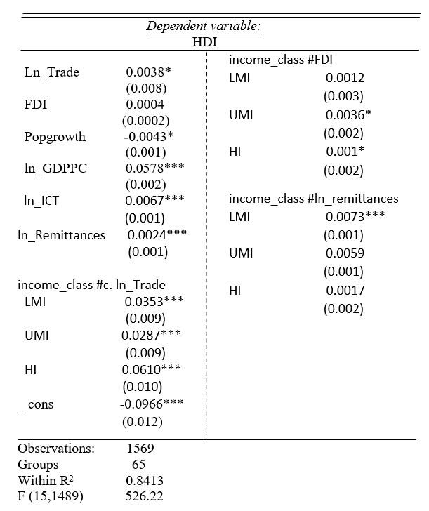**Results  
    7.1 Study 1( Impact of Economic Globalisation on Social Life, measured by HDI)**The primary factors of human development (HDI) are validated by our investigation. The findings indicate that a number of factors are important for HDI, and the proportional impacts are highlighted by log-transformed variables.   
   Although the effects of trade on human development vary according on the income level, they are generally good for LMC, UMC and HI nations**6**. Since low-income nations might not have the institutional structure or trained workforce to profit from FDI, FDI does not immediately raise HDI in these nations. On the other hand, because it puts a burden on social infrastructure and resources, population expansion seems to be a divisive factor and has a negative influence on HDI. Since technology affects how society functions, ICT**7** has also benefited HDI. HDI continues to be significantly influenced by economic growth (ln_GDPPC) for all contexts. Remittances also greatly improve life in LI because it provides supporting finances for core needs but has lesser effects in wealthier nations in which economic well -being is already high.

**Table 1- Regression Analysis(FE model)**

**Table 1- Regression Analysis(FE model)**

*5. The selected countries are listed in Appendix 1.  
6. Here, the chosen countries have been divided into 4 income groups: Higher Income(HI), Lower Income(LI), Upper Middle Income(UMI), Lower Middle Income(LMI).   
They are classified by World Bank as-  
LCs: GNI per capita of $1,135 or less, LMCs: GNI per capita between $1,136 and $4,465, UMCs: GNI per capita between $4,466 and $13,845, HICs: GNI per capita of $13,846 or more.  
7. ICT stands for Information and Communication Technology, services that enable the processing and communication of information through technology.*

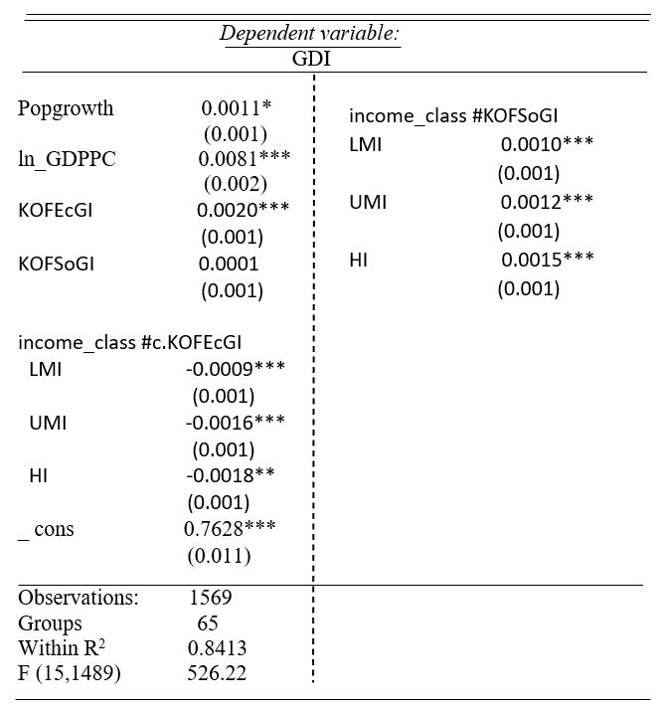**7.2 Study 2 (Impact of Globalisation on Gender Development, measured by GDI)**To investigate the relationship between Gender Development Index (GDI) and economic and social globalization across income groups, another regression analysis has been conducted. Here, Economic globalization8 shows a positive impact on gender equality by fostering economic integration. However, the strength of this relationship diminishes as income levels rise, indicating that higher-income countries already have gender equality. However for LI countries, globalisation disrupts traditional, patriarchal norms and women are more likely to engage in work thus giving financial independence to women

**Table 2- Regression Analysis(FE model)**

Social globalization9, in contrast, exhibits an insignificant direct effect on GDI, for LI countries. Nonetheless, its impact varies across other income groups, with high-income countries demonstrating a stronger positive interaction. This suggests that advanced social infrastructure in these countries enhances the benefits of social globalization for gender equality.

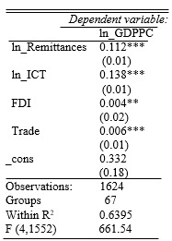 **7.3 Study 3 (Globalisation influencing economic growth)**It is hypothesized that economic indicators of globalization like remittances, ICT penetration, FDI, trade openness significantly influence GDPPC, acting as a proxy for economic development. Regression analysis largely supports this hypothesis, showing that remittances, ICT penetration, and FDI significantly contribute to GDPPC. However, trade openness, positively associated, is statistically significant, indicating a direct role in driving economic development. The findings are in line with the studies that consider the role of remittances in increasing household consumption and investments (Ratha, 2005) and the sense in which ICT can transform the driving forces into productivity and innovation (World Bank, 2016).

*8.* *The KOF Economic Globalization Index (KOFEcGI) measures the economic interconnectedness of countries through trade, investment, and capital flows, reflecting their integration into the global economy.  
9. The KOF Social Globalization Index (KOFSoGI) assesses the extent of a country's social connectivity with the world through personal interactions, information flows, and cultural exchanges.*

**Table 3- Regression Analysis(FE model)**

Similarly, FDI are also postively and significantly contributing, thus supporting theories linking FDI to capital accumulation and technological diffusion (Borensztein et al., 1998) . However this contrasts the findngs of Sachs and Warner (1995), who underlined the positive and significant impact of open trade policies. Overall, it is confirmed that globalization indeed encourages economic development in terms of higher GDP per capita, with trade openness being a weaker indicator.

**7.4 Study 4 (Globalisation and the Poor)**In order to assess how globalisation affects poor, a regression of the relationship between globalization and the income share of the bottom decile or quintile, using GDP per capita and a range of control variables10 has been carried out. The results here indicate that key variables such as Trade and Rule of Law-which are often seen as indicators of global integration-show weak or negative associations with income share in the lowest quintiles. This would suggest that the poor get left out of globalization's opportunities because they  
 lack adequate access to factors and markets, weak governance structures, and an overall protection framework through law.   
Access to markets and the banking infrastructure is crucial as measured by bank branches and the ratio of domestic bank assets to GDP in ensuring that the poor can take part in global trade and investment opportunities.

**Table 4- Regression Analysis(OLS)**

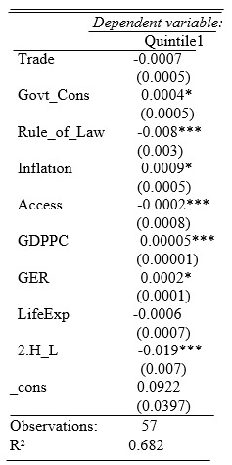  
  
Also, life expectancy and government consumption could potentially impact the benefits from globalization;however, their power is weakened because vulnerable groups lack adequate support systems. Indeed, the results here indicate that globalization does not necessarily seem to help the poor based on Dollar and Kraay (2004), who found that globalization's benefits tend to be disproportionately captured by the wealthier segments of society.

**7.5 Study 5 (Analysing Social Mobility pre vs post Globalisation)**

|  |  |  |  |  |  |  |  |
| --- | --- | --- | --- | --- | --- | --- | --- |
|  |  |  | | **MOBILITY MATRIX 1(1970-1990)** | | | |
|  |  | |  |  | **1990** | |  |
|  |  | | **0.25** | **0.5** | **1** | **2** | **∞** |
|  | **0.25** | | *100.00%* | *0.00%* | *0.00%* | *0.00%* | *0.00%* |
|  | **0.5** | | *8.33%* | *83.33%* | *8.33%* | *0.00%* | *0.00%* |
| **1970** | **1** | | *0.00%* | *66.67%* | *33.33%* | *0.00%* | *0.00%* |
|  | **2** | | *0.00%* | *0.00%* | *0.00%* | *85.71%* | *14.29%* |
|  | **∞** | | *0.00%* | *0.00%* | *0.00%* | *40.00%* | *60.00%* |

An analysis of the mobility matrices11 for the two periods, 1970–1990 and 1990–2019, reveals the transformative effects of globalization on economic mobility. Income transitions experienced strong persistence in the earlier period (1970-90) (Table 6a) with limited upward movement, a symptom of rigidly structured economic hierarchies in many places,reflecting restricted access to global markets and resources. For instance, 100% of entities in the lowest income category (1/4) persisted there, and very few left this category for higher ones, indicating no significant economic possibility (Quah, 1993; Milanovic, 2005).

**Table 6a- Mobility Matrix 1**

|  |  |  |  |  |  |  |
| --- | --- | --- | --- | --- | --- | --- |
|  |  |  | **MOBILITY MATRIX 2(1990-2019)** | | | |
|  |  |  |  | **2019** | |  |
|  |  | **0.25** | **0.5** | **1** | **2** | **∞** |
|  | **0.25** | *57.69%* | *34.62%* | *7.69%* | *0.00%* | *0.00%* |
| **1990** | **0.5** | *0.00%* | *33.33%* | *50.00%* | *16.67%* | *0.00%* |
|  | **1** | *0.00%* | *0.00%* | *60.00%* | *40.00%* | *0.00%* |
|  | **2** | *0.00%* | *50.00%* | *0.00%* | *0.00%* | *50.00%* |
|  | **∞** | *0.00%* | *0.00%* | *0.00%* | *0.00%* | *100.00%* |

However, it shows that within the 1990–2019 period(Table 6b), there was high mobility upwards, especially for the lower income groups, as only 57.69% of entities persisted in the lowest category, while many climbed up to levels such as (1/2) and (1). This reallocation aligns with the increased depth of global integration described by increased openness in international trade, technology, and education, especially in developing economies (Dollar & Kraay, 2004; Sachs & Warner, 1995). However, the highest income class still persisted at 100% with the same entities, indicating that globalization has made global inequality more deep-rooted because benefits often accrue to those who are already more privileged (Piketty, 2014; Stiglitz, 2002). These trends underscore the dual character of globalization: encouraging mobility and growth, but reinforcing inequality; therefore, policy must intervene to correct its uneven distributional effects.

**Table 6b- Mobility Matrix 2**

*10. Consisting of observations from more than 70 countries, over 1980-2019. We focus on the cross-section of 2018   
Here controls used are namely Trade (Trade), Inflation (Inflation), Government consumption (Govt_Cons), Rule of law (Rule_of_Law), No. of bank branches per 100,000 adults (Access), Life Expectancy Rate (LifeExp), Unemployment Rate (UER), Gross Enrolment Ratio (GER), high- or low-income group (H_L).  
11. A mobility matrix is a tool used to measure and visualize the movement of individuals or groups across different socioeconomic or income levels over time, highlighting patterns of upward, downward, or stagnant mobility.*

1. **Conclusion**

In summary, according to the analysis in this paper, globalization is an extremely powerful force with extremely nuanced outcomes that exerts significant economic, social, and cultural impacts. It is probably hard to deny that it has triggered economic growth plus technological development as well as making social mobility better than before. The distribution of its benefits and costs, however, reveals very stark disparities between high-income countries, which have more effectively capitalized on the new levels of global interaction, and low-income countries, which have systemic impediments that do not allow them to realize those gains similar to the findings of Sapkota, 2011 in her paper.   
  
Reflecting on income inequality and environmental degradation, proper policy framework adjustments are required . Therefore, the governance, infrastructure deficits, and institutional reforms in vulnerable regions need to be properly addressed for inclusivity and sustainability just like what Milanovic, 2016 concluded through his paper on how globalization exacerbates social and economic inequalities. This study highlights that globalization is not one simple thing, rather a very complex interaction of forces where intentional effort must be made to manage it so that all the advantages can be shared equitably.

*Way Forward:* To reduce inequality and enhance the Quality of Life, policies should promote inclusive economic growth through progressive taxation, fair wages, and SME support, alongside robust social safety nets and affordable education. Investments in healthcare, preventive care, and education modernization are essential, with incentives for school attendance and job creation in sustainable sectors. Gender equality efforts should include scholarships, equal pay, financial access for women, and anti-discrimination laws, alongside addressing gender-based violence. Global collaboration should enforce fair trade, corporate accountability, and digital inclusion, leveraging technology for e-governance, telemedicine, and e-learning while empowering local communities and ensuring equitable land rights. The ulterior motive of globalization should one day place equity alongside progress to build a better, fairer global community.

1. **Appendix**

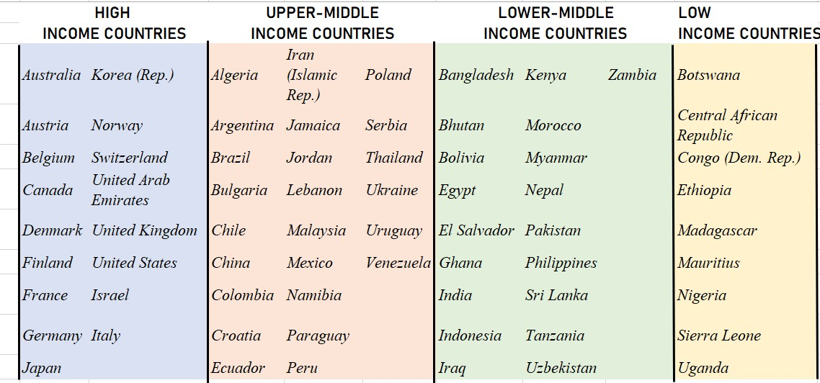**9.1 Table listing the countries(60) chosen for our observation from 1990-2019**

1. **References:**

1. World Bank. (n.d.). Data. Retrieved from https://data.worldbank.org

2. International Monetary Fund. (n.d.). IMF data. Retrieved from https://www.imf.org/en/Data

3. United Nations Development Programme (UNDP). (n.d.). Human Development Reports Data Center. Retrieved from https://hdr.undp.org/data-center

4. UNU-WIDER. (n.d.). World Inequality Database on Education. Retrieved from https://www.wider.unu.edu/

5. Dreher, A. (2006). Does globalization affect growth? Evidence from a new index of globalization. Applied Economics, 38(10), 1091–1110. https://doi.org/10.1080/00036840500392078

6. MacKenzie, D. W. (2004). [Review of Globalization and Its Discontents by J. E. Stiglitz]. Public Choice, 120(1/2), 234–239. Retrieved from http://www.jstor.org/stable/30025840

7. Feenstra, R. C., & Hanson, G. H. (1997). Foreign direct investment and relative wages: Evidence from Mexico's maquiladoras. Journal of International Economics, 42(3–4), 371–393. https://doi.org/10.1016/S0022-1996(96)01475

8. Gariba, M., & Provazníková, R. (2023). A panel regression analysis of the role of globalization and internet penetration on economic development in the Czech Republic and Slovakia. European Conference on Knowledge Management, 24, 384–393. https://doi.org/10.34190/eckm.24.1.1295

9. Bhagwati, J. (2004). In defense of globalization. New York, NY: Oxford University Press. Retrieved from https://scholarship.law.columbia.edu/books/191

10. Kumar, S., & Singh, K. (2012). Impact of globalization: The Indian experience. International Journal of Economics Commerce and Research, 2(1), 1–10.

11. Rodrik, D. (1997). Has globalization gone too far? Washington, DC: Institute for International Economics.

12. Patnaik, P. (2014). Capitalism, inequality, and globalization: Thomas Piketty’s Capital in the Twenty-First Century. International Journal of Political Economy, 43(3), 55–69. https://doi.org/10.2753/IJP0891-1916430304

13. Heimberger, P. (2021). Does economic globalisation promote economic growth? A meta‐analysis. The World Economy, 45(1), 10. https://doi.org/10.1111/twec.13235

14. Huynen, M. M., Martens, P., & Hilderink, H. B. (2005). The health impacts of globalisation: A conceptual framework. Global Health, 1(1), 14. https://doi.org/10.1186/1744-8603-1-14